The pumped storage power plant - the intelligent electricity storage system

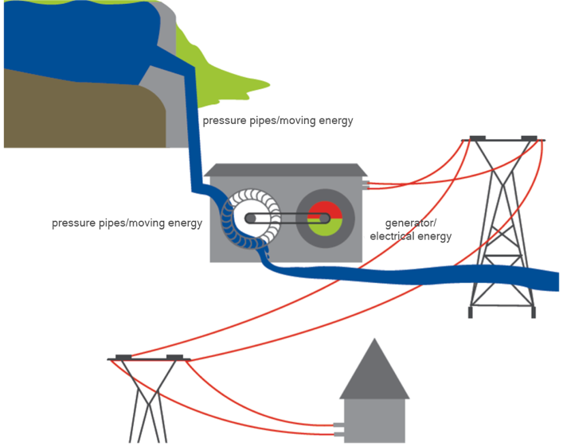

In just a few seconds, a pumped storage power plant can be set to either storage or generation mode: Depending on whether there is too much or too little electricity available.

### How does a pumped storage power plant work?

A pumped storage power plant utilises the difference in height between a reservoir and the powerhouse with the turbines. The water is channelled into tunnels where it ‘plunges’ up to 500 metres into the depths. At the end of the tunnel, the water meets turbines that set it in motion. The turbines drive generators and these generate electricity. The special thing about pumped storage power plants is that the reverse process is also possible. This means that water can be pumped from a river or lake into a higher reservoir.

### Pumped storage power plant under construction

### What are the advantages of generating electricity in pumped storage power plants?

What works well with small accumulators or simple batteries is not possible on an industrial scale in large quantities: electricity cannot yet be stored very efficiently. Therefore, as much electricity must be generated at any given time as is currently being consumed; but also as much must be consumed as is being generated. And not just in Austria, but throughout Europe.  
  
Nature has a different rhythm

The more alternative energy sources are used in Europe - e.g. solar plants  
 in the sunny south in the sunny south, wind turbines in the stormy north - the less predictable electricity generation becomes. This is because the time at which the sun shines or the wind blows does not always coincide with human habits of electricity consumption.  
  
The pumps run at night ...

In the long term, pumped storage power plants are the only way to store electricity efficiently. If, for example, a lot of electricity is available at night from wind power plants, water is pumped from a lower reservoir to a higher one. The surplus energy from the wind is therefore stored in the form of work.  
  
... and the turbines during the day

If more electricity is consumed during the day than is currently being generated, water can be drained from the reservoir into a lower-lying powerhouse within a few seconds, where the water pressure drives a turbine. This means that electricity can be fed into the grid within a few minutes if required.  
  
With pumped storage, the same water can be used several times to store electricity in an economically and ecologically sensible way.

The safety of dams is an important issue. Dams are among the best-monitored structures in Austria. The key to safety lies in robust construction, comprehensive monitoring of each facility by automatic sensors and our own staff on site.

### Renewable and non-renewable energy sources

|  |  |
| --- | --- |
| Renewable | Non-Renewable |
|  | Coal |
|  |  |